**PROGRAMMING ASSIGNMENT # 9**

**MIKAELA G. SANTOS – 2ECE-A**

*Problem 1*

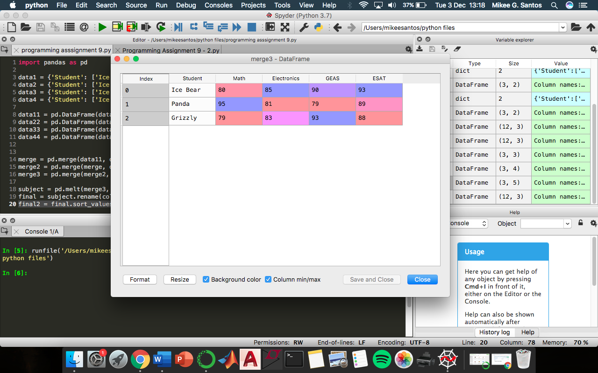

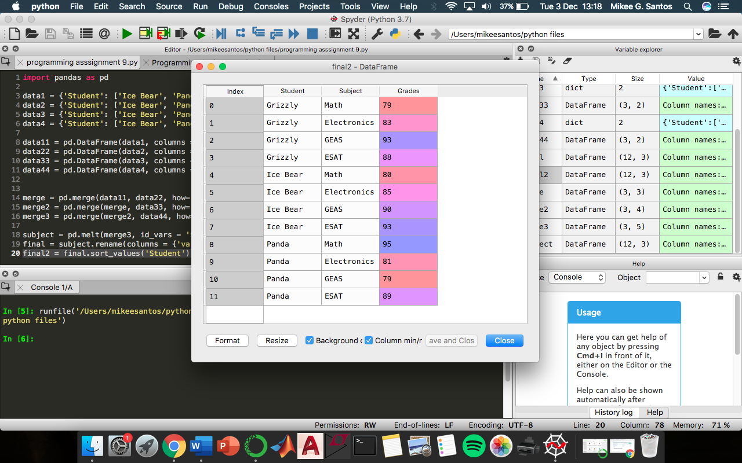

*Problem 2*



